ESNN Technique

Advantages:

The ESNN technique effectively diminishes the prediction error in noise free patches that deblurs the lower contrast image details with minimum signal to noise ratio.

ESNN can handle noisy input data effectively, as it relies on the reservoir's ability to filter and process noise over time.

In ESNN technique, the same image patches are determined by calculating the distance between the image patches with similar size of μ,:

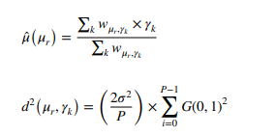

Disadvantages (**reason for the need for the Steerable Pyramid Transform**):

Though ESNN technique is efficient but has an issue of shift-invariant., because of which there is the need to develop this Steerable Pyramid Transform (SPT) technique.

The SPT is a multi-orientation and multi-scale transformation technique, which delivers useful frond end for image denoising application.

SPT is applied on the output image of ESNN technique by dividing the image into several orientations and scales.

Here, low pass filter Lo and high pass filter Ho are applied to decompose the images into lower and higher frequency components.

Output of the frequency domain is mathematically given in the paper as:  
  


**But according to me, the application of hard thresholding to enhance visibility can lead to information loss. Depending on the thresholding parameters, important image details may be suppressed.**

**Overall Result: Satisfactory**

**Inference: Paper contains two many derivations making it harder to understand the ESNN technique.**

**About Steerable Pyramid Transform the content is too less.**